Assignment 03/12/2020

Name – Archisman Roy

CSE 2nd year 3rd sem

Roll – 50

1) Write a program to get the maximum and minimum value in a dictionary.

2) Write a program to store student data in dictionary (name, class, subjects). Remove duplicate entries.

3) Write a Python program to concatenate following dictionaries to create a new one using loop.

4) Write a Python program to multiply all the items in a dictionary.

5) Write a Python program to sort a dictionary by key.

6) Write a Python program to check a dictionary is empty or not.

7) Write a Python program which creates two dictionaries. One that stores conversion values from meters to centimeters and the other that stores the reverse.

8) Write a Python program that inverts a dictionary, i.e., it makes key of one dictionary value of another and vice versa.

Outputs :

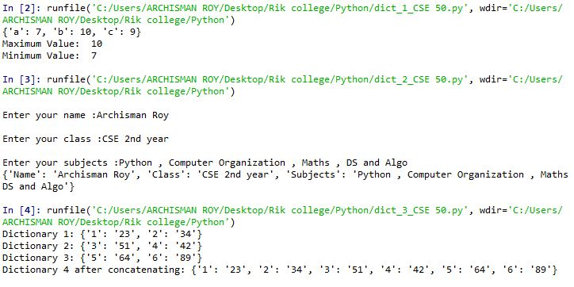

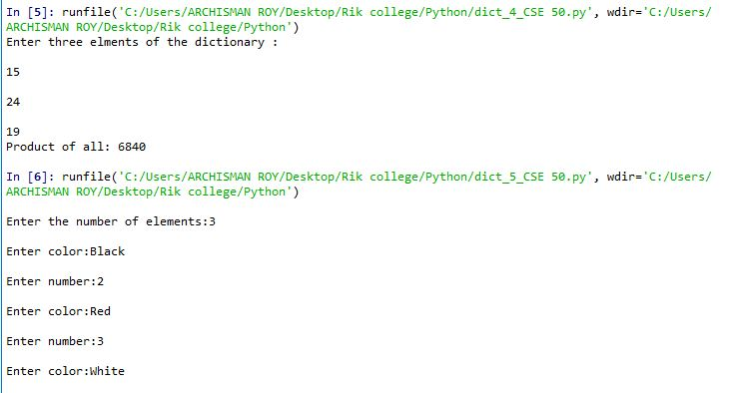

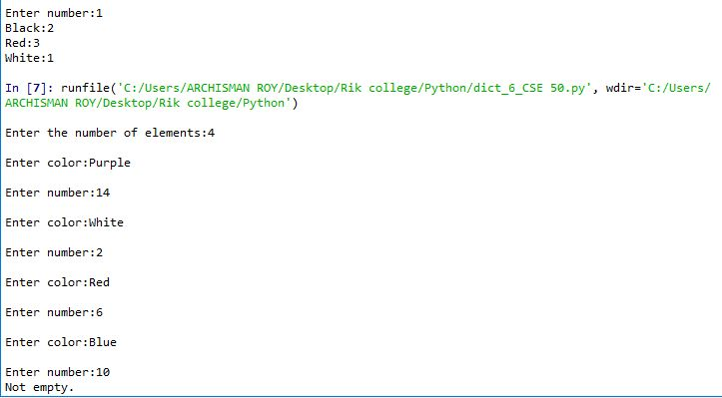

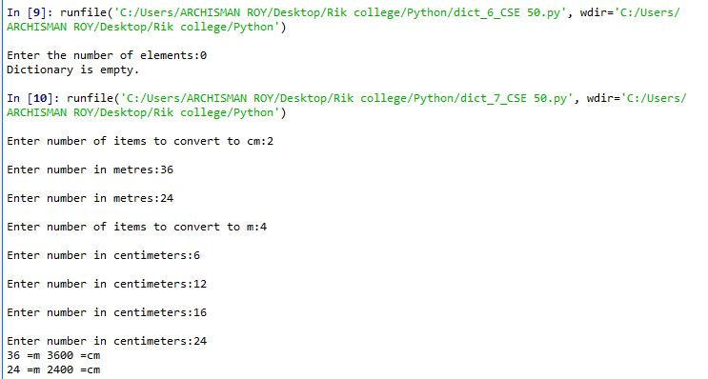

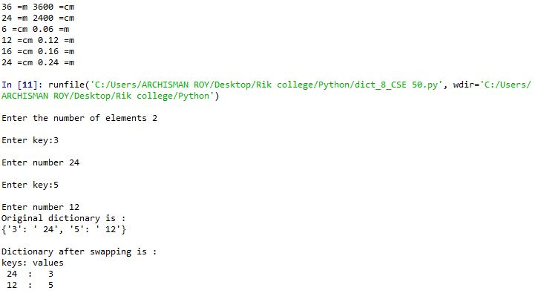

Questionnaires:

1. What are the advantages of dictionary over list?

Ans.

1. Dictionaries allow key-pair usage and hence accessing elements are easier since we do not need to remember the indices at which they are stored.

ii. It is also more efficient to use a dictionary for lookup of elements because it takes less time to traverse in the dictionary than a list.

1. No order has to be maintained in dictionary since we can always access them via key-pair usage.